PROGRAM 4. You are to develop an application that reads student records from a sequential file that is stored inside the Debug folder of the application. For each student, there are 4 related records: the student’s name, and the next 3 lines are the grades the student earned in the 3 course exams. Your program will process each group of 4 lines for each student, compute the average exam grade, compute the corresponding letter grade, and display the name, score, and grade on one line in a listbox. The number of students in the file is NOT known.

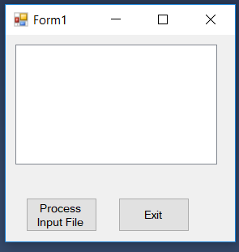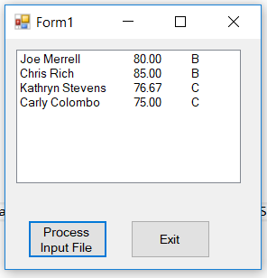

The Input data file will look as such:

Alan M. Turing

100

100

100

Grace Hopper

89

88

87

\*

\*

\*

\*